Name : Ma Hnin Yee Aye

Case study 4

Task(1)

1. Admin Entity

* admin_id
* admin_name
* admin_password
* admin_email

1. Customer Entity

* cus_id
* cus_name
* cus_phoneNo
* cus_account
* cus_address
* cus_admin_id

1. Staff Entity

* staff_id
* staff_name
* staff_phoneNo
* staff_admin_id

1. Payment Entity

* payment_id
* payment_amount
* payment_date
* payment_cus_id
* payment_admin_id

1. Profit Entity

* profit_id
* profit_amount
* profit_date
* profit_payment_id

Task 3: ER Diagram for case 4

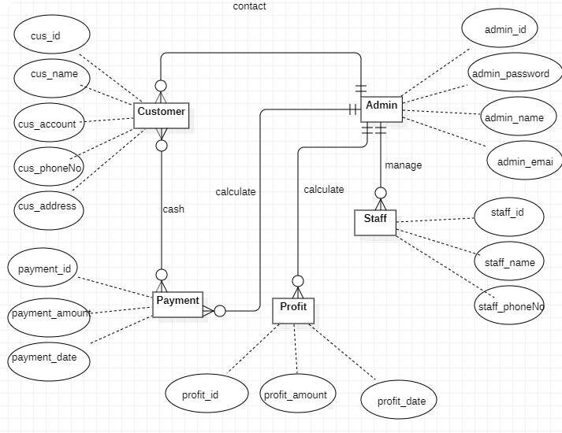

Task 3:Class Diagram for case 4

